#### PREVENTION

#### *The Federal Emergency Management Agency of the U.S. Fire Administration recommends:*

# Always keep matches and lighters out of the reach of small children.

* **Be emphatic; Tell the child “No! You are not to play with matches and lighters! They can burn and hurt you!”**
* **Always supervise a young child in a room where an open flame is present (fireplace, candles, heaters, etc.).**
* **Teach young children that matches and lighters are tools, not toys. With adult supervision, demonstrate how you can cautiously use these tools.**
* **Closely supervise and teach a child how to safely strike a match or light a candle.**
* **Never leave young children unattended, even for short periods.**
* **Hire only experienced, trained babysitters.**
* **Teach children about fire when they first show interest. Discuss the proper use of fire and how destructive fire is if it is not used safely.**

If your child, or someone you know is experimenting with or setting fires, call the:

Wooster City Fire Department

330-263-5266

Wooster City Fire Department

510 N. Market St.

Wooster, Ohio 44691

330-263-5266

Fax: 330-263-5281

**Juvenile Firesetter Education Program**

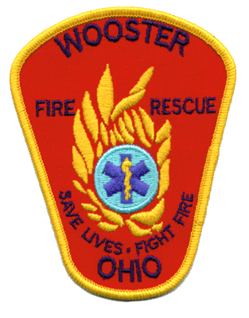



**Fireplay-**

**A Deadly Game**

Fireplay is a deadly game that should not be dismissed as a “phase” or simple “curiosity.” Records show that at least 50 percent of the approximate 600,000 residential fires in the United Sates are caused by children.

Children must be properly educated about fire’s destructive power.

**Children start fires for many reasons:**

* Curiosity / Experimental
* Imitating Behavior
* Peer Pressure
* Due to Crisis
* Anger / Revenge
* During Illegal Activity

**Whatever the reason, there is help through the Wooster City Fire Dept. Juvenile Firesetter Program**

The Wooster City Fire Dept. offers free educational classes to all children who live in Wooster. The classes include fire safety, fire danger, consequences, and arson laws.

If counseling services are needed, referrals can be made by the Division.

**Each year in the United States millions of dollars of property are lost and hundreds of deaths are caused by juveniles who set fires.**

**According to the National Safe Kids Campaign:**

* Child-curiosity fires are the leading cause of residential fire-related death and injury among children ages 9 and under.
* Fire and burns are the third leading cause of unintentional injury-related death and children ages 14 and under.